SMT. CHANDANBEN SHANTILAL SWARUPCHAND SHAH
B.C.A. COLLEGE, DEESA
PH.NO:-02744-224300
(Affiliated By: H.N.G.University, Patan)
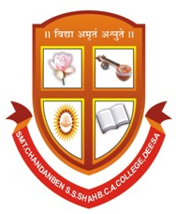

Certificate
This is certify that
Roll No | Name Of Student | Exam No
30 | Solanki Piyush Sanjaykumar
24 | Rajgor Dhavalkumar Tagajibhai
04 | Daiya Jaykumar Bharatbhai

Of B.C.A SEMESTER - VI have successfully completed the project work on:

BCA 605: SYSTEM DEVELOPMENT PROJECT (2020-21)
Project Title:-” Online Shoes Shopping ”

Date : 31/05/2021
Place : DEESA

Internal Project Guide Principal
(Pro. H.O.MAIDH) (Pro. H.O.MAIDH)

